**FOP Lodge 88**

(402) 413-5265

***Meet and Greet***

***39012 Drive 716 McCook***

All employees and family welcome.

**October 7**

**12 p.m. – 4 p.m.**

Bring your chairs and drinks.

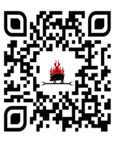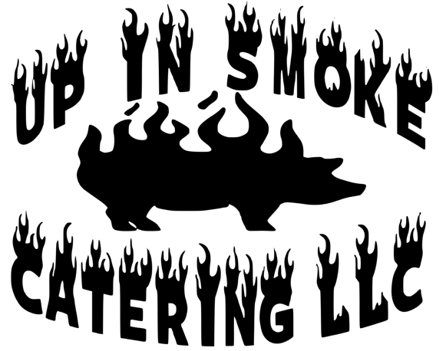Pulled pork and Brisket sandwiches With sides will be provided by: